**Location map of Mitraniketan:**

Mitraniketan is located in Trivandrum district (currently known as Thiruvananthapuram district) which is located in the far south of Kerala State & south west of India. The main campus of Mitraniketan is situated 25 km from Trivandrum city (30 Km from Trivandrum airport) in a village known as VELLANAD which is a hilly region with lot of rubber plantations along with farming.

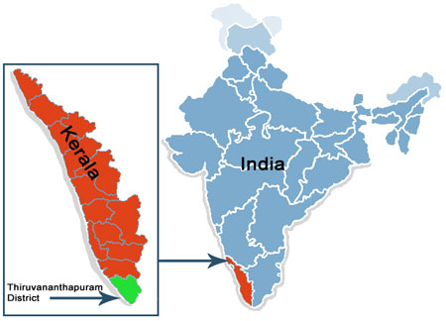

**Geographical area profile:**

The land is mainly used for rubber plantations in the hilly region, and is also used for cultivation of coconut, banana and other edible crops. However, cultivation of Paddy/rice is on the diminishing side. Average rain fall in the area ranges from 1300-1500mm per year while soil type ranges from lateritic in hill tracts, red loam in the mid lands and sandy loams in coastal areas. Topography of the place is undulating and there exists water scarcity during the summer months.

People in the regions are mainly farmers, but young generation among them moved away from agriculture to non farm activities due to better opportunities of education.