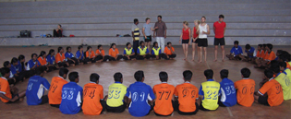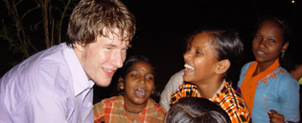

World Education for XXI Century Enlightenment
MITRANIKETAN, Kerala INDIA 29.January – 4.February 2012

Arranged by Association for World Education and Mitraniketan

What is the state of human growth and evolution in the early years of this 21st Century? What is called for from our beings to step into this new era? What kind of education can support this development? This two-part AWE Seminar is designed to examine these questions through an in-depth dialogue with educators from around the world, with special attention to the circumstances and experience in Kerala, India.

AWE Working Seminar (Part 1): AWE educators invite their members and colleagues to join a participatory examination of our perspectives on opportunities for enlightenment, along with our best practices for creating whole, world centric human beings.

Sunday 29.1: Afternoon: A personal workshop for all: “Awakening the leader from within.”
Evening Program: Dinner, welcome, and overview and purpose of the Enlightenment Project,
review agenda for the week.

Monday 30.1: Themes for the day: “What is Enlightenment for the 21st Century?”
“What are the opportunities for uncovering and nurturing enlightenment?”
Morning: Keynote panel and discussion.
Afternoon: Field Study at Mitraniketan: 4 themes: religion and philosophy, food for health
and medical care, entrepreneurship, and changing women’s rights and roles.
Evening: Gathering of regional stories. (with day’s theme: “Opportunities toward
enlightenment”).

Tuesday 31.1: Theme for the Day: “What is an enlightened teacher for the 21st century?”
Day: Presentations, dialogue, and gathering of regional stories.

Wednesday 1.2:
Morning: Drawing together a synthesis of discussions from Monday and Tuesday.
Afternoon: Cultural tour and dinner.

Seminar (part 2): Life Enlightenment through World Education

Thursday 2.2 and Friday 3.2: The AWE Working Seminar group is joined by regional educators, community
leaders, and students for a more Indian-focused, 2-day dialogue on past, present and future
perspectives on world education.

Themes for Thursday and Friday: Personal enlightenment of teachers; Global Networking for educators; New technology and social media as a new challenge in pedagogical work.

AWE Working Seminar (Part 1), Conclusion
Saturday 4.2: Our AWE Working Seminar Group reconvenes to gather recommendations and summaries in
response to the study questions: What is Enlightenment? What are the opportunities for
uncovering and nurturing enlightenment? What is an enlightened teacher for the 21st
Century? All participants are welcome to join.

World Education for XXI Century Enlightenment
MITRANIKETAN, Kerala INDIA 29.January – 4.February 2012
Arranged by Association for World Education and Mitraniketan

Who can participate?
We invite educational thinkers, educators and teachers from all over the world who would like to be part of this in-depth dialogue. It is our goal to better define our AWE common ground on the essential questions that are listed in the daily schedule – and we welcome our “kin” from the greater world of global thinkers and adult educators. Due to the nature of the facility and our desire for an intimate conversation, numbers are limited to 30 international participants and 30 local participants.

Price and what is included?
Price: $600 (US) - AWE members $450 (US)

Includes:

Lodging: in the Mitraniketan guesthouse: The Guesthouse is a basic facility with cots, beds, table, chair, fan, Indian toilets. Double rooms have shared toilets. Those with special needs requiring a single room are asked to send a special request.

Meals: Indian breakfast, lunch & dinner at 8am, 1.00, & 7 pm. (Dinner Wednesday evening is not included.)

Transportation: Transportation from Trivandrum (airport) to Mitraniketan; local transportation Monday, Tuesday, and Wednesday; Transportation to Trivandrum on Saturday.

How to Register
Register by sending an e-mail to Rikke Schultz, Landevejen 6, 5683 Haarby, e-mail: Treasurer@awe-international.com. You will receive instructions on making a $200 deposit to hold your reservation. When this is received, a confirmation will be sent. Balance of payment will be due in cash upon arrival at Mitraniketan.

Questions about your stay in Mitraniketan can be addressed to:
Dr.Reghu Rama Das, Mitraniketan, Vellanad, Trivandrum-695 543, Kerala, e-mail: kvmitra@sify.com


MITRANIKETAN is an experimental non-profit social and educational project, founded by K.Viswanathan near Vellanad, his native village, 30 km from Trivandrum, the capital of Kerala in south India. The project started with offering education and training in a holistic spirit to primarily socially underprivileged children and youngsters. The organization focuses on alternative education methods for development. Read more: http://www.mitraniketan.org

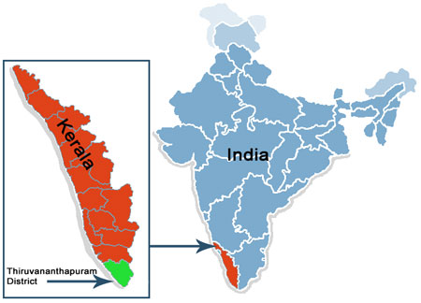
Association for World Education (AWE) is an international NGO with consultative status in the United Nations and with more than 20 chapters across the world. AWE is a network of individuals and organizations that work with innovative methods of education, democracy, human rights and cultural exchange across the globe. AWE works primarily in the areas of Education, Democracy and Human Rights. Read more: http://www.awe-international.com

